**TECHNICAL REPORT ON PROJECT 3.**

**BY**

**ADEGOKE BLESSING TUNMISE**

**VEPH/20B/DA189**

**Task 16B (iii)**

**ANALYSIS OF DATA INDUSTRY JOBS AND SALARY DISTRIBUTION**

OUTLINE

1.     Introduction

2.     Story of Data

3.     Data Splitting

4.     Pre-Analysis

5.     In-Analysis and Insights

6.     Data Visualization

7.     Recommendations and Observations

8.     Conclusion

**1. Introduction**

This report presents an analysis of salary distribution and job dynamics within the data industry. The study examines variations in salary based on job titles, experience levels, work settings, employment types, and geographical attributes. The insights aim to guide professionals, recruiters, and stakeholders in making informed decisions about hiring and career development.

**2. Story of the data**

The dataset provides detailed records of job roles in the data industry across multiple countries for the year 2023. It captures compensation figures and organizational attributes including job type, work settings, employee residence, company size, and more.

**Data Structure:**

* **Rows**: Each row represents an individual job role.
* **Columns**: Job Title, Job Category, Salary, Work Setting, Employment Type, Experience Level, Company Location, and Size.

**3.Data Splitting**

**Independent Variables:**

* Job Title
* Job Category
* Employee Residence
* Work Setting
* Company Location
* Company Size
* Employment Type
* Experience Level

**Dependent Variable:**

* Salary

**4. Pre-Analysis and Intended Insights**

The analysis aims to address the following questions:

* Which job roles and categories yield the highest average salary?
* How does experience level affect salary?
* What are the salary implications of work setting (remote, hybrid, in-person)?
* Does company size impact salary levels?
* How does geography influence compensation (employee residence vs. company location)?

**5. In-Analysis**

* **Top Paying Roles:** Data Architects and Data Scientists tend to earn the highest average salaries.
* **Experience Level:** Senior-level professionals command significantly higher salaries than mid-level and junior roles.
* **Work Setting:** In-person jobs show higher salary ranges on average compared to hybrid or remote roles, indicating a premium for on-site expertise.
* **Company Size:** Large companies (L) tend to offer higher salaries, followed by medium (M), and small (S) companies.
* **Geographic Influence:** Jobs based in the United States consistently offer the highest salaries, both from the perspective of employee residence and company location.

**6. DATA VISUALIZATION**

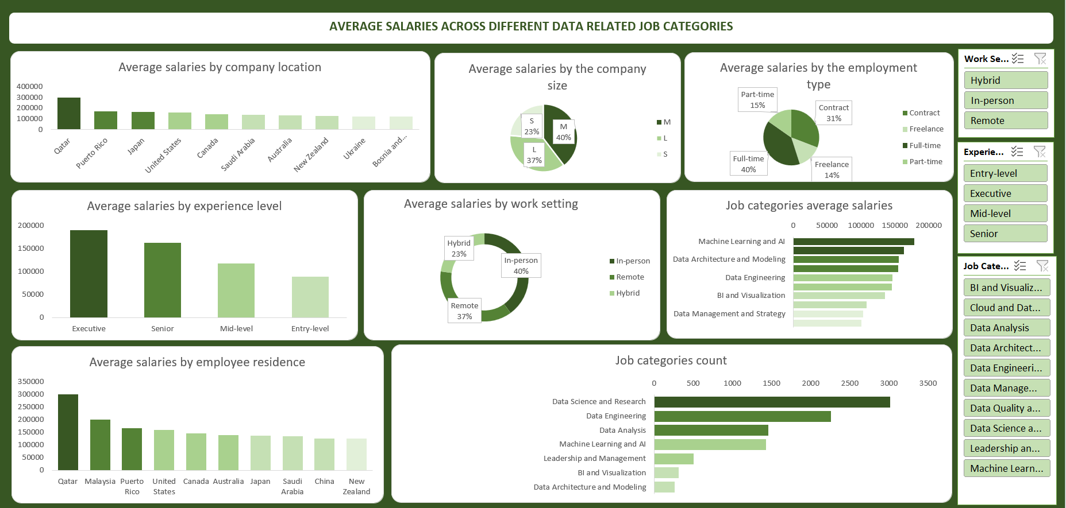

7. **Recommendations**:

* **Career Guidance:** Professionals seeking higher pay should consider advancing to senior roles and targeting high-paying categories like Machine learning and AI job.
* **Remote Strategy:** Employers may consider hybrid models to balance salary offerings and employee preferences.
* **Geographic Expansion:** Companies looking to save costs could explore hiring in regions with competitive salaries but lower living costs.
* **Growth Strategy for Small Companies:** Smaller firms should offer additional non-monetary benefits to remain competitive in attracting talent.
* **For Companies:** To attract top talent, organizations should consider offering competitive salaries, particularly for senior-level positions.

**8. Conclusion:**

The dataset reveals clear trends in how salary is distributed across roles, experience, work environment, and geography in the data industry. By leveraging these insights, stakeholders can make strategic decisions for both workforce planning and individual career development.